**England Netball hosts the ParaNetball School Championships for people with Special Educational Needs and Learning Disabilities.**

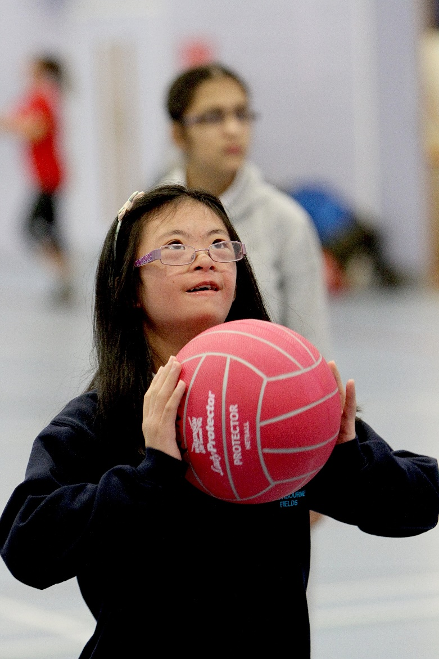

**Date:** Friday 14th June 2019

**Venue:** Lee Westwood Sports Centre, Nottingham Trent University, NG11 8SN

**Division:** School

**Entry Deadline:** Friday 31st May 2019

**Price:** Free

Email entry forms to [compevents@englandnetball.co.uk](mailto:compevents@englandnetball.co.uk)

Availability is limited, places will be awarded on a first come first served basis.

Name of School: Region:

Kit Colours – Skirt/ Shorts: Shirt: Bibs: Dress:

|  |  |  |  |  |  |
| --- | --- | --- | --- | --- | --- |
|  | **Name** | **D.O.B.** | **Gender** | **Disability** | **School Contact Address** |
| **1** |  | **/ /** |  |  |  |
| **2** |  | **/ /** |  |  |
| **3** |  | **/ /** |  |  |
| **4** |  | **/ /** |  |  |
| **5** |  | **/ /** |  |  |
| **6** |  | **/ /** |  |  |
| **7** |  | **/ /** |  |  |
| **8** |  | **/ /** |  |  |
| **9** |  | **/ /** |  |  |
| **10** |  | **/ /** |  |  |
| **11** |  | **/ /** |  |  |
| **12** |  | **/ /** |  |  | **School Email Address** |
| **COACH** |  | **Phone Number** |  |  |  |
| **PRIMARY CARER** |  | **Phone Number** |  |  |
| **TEAM OFFICIAL 3** |  |  |  |  |
| **TEAM OFFICIAL 4** |  |  |  |  |
| **TEAM OFFICIAL 5** |  |  |  |  |
| **SCORER \*** |  | **Phone Number** |  |  |
| **EMERGENCY CONTACT** |  | **Phone Number** |  |  |

Team Manager / Coach Signature:

*(*Any additional scorers please complete on separate sheet)*